
ST. SIMEON ORTHODOX CHRISTIAN CHURCH
A Mission of the Antiochian Orthodox Christian Archdiocese of North America
Primate- His Eminence Metropolitan JOSEPH, Archbishop of New York and Metropolitan of all North America
28042 Ave. Stanford, Suite D
Santa Clarita, CA 91355
Mailing Address: P.O. Box 800992 Santa Clarita, CA 91380
www.scvorthodox.com

V. Rev. Fr. George Ajalat, Pastor (626) 664-8274 Gajalat@gmail.com

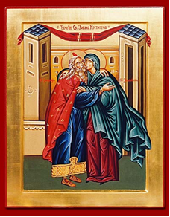

Sunday, October 17, 2021
Tone 8 / Eothinon 6
Sunday of Holy Fathers of Seventh Ecumenical Council & Fourth Sunday of Luke
Prophet Hosea; Venerable-martyr Andrew of Crete

WELCOME!
“The Newest Church in Santa Clarita is the Oldest Church in the World.”
St. Simeon Orthodox Church welcomes all of you to our community this Sunday- for truly, “This is the Day that the Lord has made.” We are honored to have you worship with us. If you are new to our community or simply have any questions, please introduce yourselves to Fr. George after the Divine Liturgy. He would love to meet you. Submit bulletin information to: stsimeonbulletin@gmail.com by 9pm on Wednesday.
RESURRECTIONAL APOLYTIKION IN TONE EIGHT
From the heights Thou didst descend, O compassionate One, and Thou didst submit to the three-day burial, that Thou might deliver us from passion; Thou art our life and our Resurrection, O Lord, glory to Thee.

APOLYTIKION OF THE HOLY FATHERS IN TONE EIGHT
Thou, O Christ, art our God of exceeding praise Who didst establish our Holy Fathers as luminous stars upon earth, and through them didst guide us unto the true Faith, O most merciful One, glory to Thee.

TROPARION FOR ST. SIMEON IN TONE ONE
Rejoice, thou who art full of grace, O Virgin Theotokos, for from thee hath risen the Sun of Righteousness, Christ our God, enlightening those in darkness. Rejoice, thou also, O righteous Elder, as thou receivest in thine arms the Redeemer of our souls, Who also granteth unto us the Resurrection.

ORDINARY KONTAKION IN TONE TWO
O protectress of Christians that cannot be put to shame, and their constant intercessor before the Creator; despise not the petitions of us sinners who are imploring you; in your goodness come to our help, who in faith cry unto you: Hasten O Theotokos to intercede for us, and hurry to pray for us! For you have always protected those who honor You.

THE EPISTLE
(For the Holy Fathers)
Blessed are Thou, O Lord, the God of our Fathers.
For Thou art just in all that Thou hast done to us.
The Reading from the Epistle of St. Paul to St. Titus. (3:8-15)
Titus, my son, faithful is the saying, and concerning these things I desire you to affirm confidently, that those who have believed in God may be thoughtful of how to preside in honorable occupations. These things are good and profitable to men. But avoid foolish disputes, and genealogies, and contentions, and controversies about the Law; for they are unprofitable and vain. A man who is a heretic after the first and second admonition reject, knowing that such a one is subverted, and sins, being self-condemned. When I send Artemas to you, or Tychicós, give diligence to come to me to Nicopolis; for I have determined to winter there. Set forward Zenas the lawyer and Apollos on their journey diligently, that they may be lacking in nothing. And let our people also learn how to preside in honorable occupations, so as to help in cases of urgent need, that they should not be unfruitful. All who are with me salute you. Salute those who love us in the faith. Grace be with you all. Amen.

THE GOSPEL
(For the Fourth Sunday of Luke)
The Reading from the Holy Gospel according to St. Luke. (8:5-15)
The Lord spoke this parable: “A sower went out to sow his seed; and as he sowed, some fell along the path, and was trodden under foot, and the birds of the air devoured it. And some fell on the rock; and as it grew up, it withered away, because it had no moisture. And some fell among thorns; and the thorns grew with it and choked it. And some fell into good soil and grew, and yielded a hundredfold.” And when His Disciples asked Him what this parable meant, Jesus said, “To you it has been given to know the secrets of the kingdom of God; but for others they are in parables, so that seeing they may not see, and hearing they may not understand. Now the parable is this: The seed is the word of God. The ones along the path are those who have heard; then the devil comes and takes away the word from their hearts that they may not believe and be saved. And the ones on the rock are those who, when they hear the word, receive it with joy; but these have no root, they believe for a while and in time of temptation fall away. And as for what fell among the thorns, they are those who hear, but as they go on their way, they are choked by the cares and riches and pleasures of life, and their fruit does not mature. And as for that in the good soil, they are those who, hearing the word, hold it fast in an honest and good heart, and bring forth fruit with patience.” As Jesus said this, He called out, “He who has ears to hear, let him hear.”

THE DISMISSAL
Priest: May He Who rose from the dead, Christ our true God, through the intercessions of His all-immaculate and all-blameless holy Mother; by the might of the Precious and Life-giving Cross; by the protection of the honorable Bodiless Powers of Heaven; at the supplication of the honorable, glorious Prophet, Forerunner and Baptist John; of the holy, glorious and all-laudable apostles; of our father among the saints, John Chrysostom, archbishop of Constantinople, whose Divine Liturgy we have now celebrated; of the holy, glorious and right-victorious Martyrs; of our venerable and God-bearing Fathers, especially the 367 Holy Fathers of the Seventh Ecumenical Council; of Saint N., the patron and protector of this holy community; of the holy and righteous ancestors of God, Joachim and Anna; of the holy and glorious Prophet Hosea; and Venerable-martyr Andrew of Crete, whose memory we celebrate today, and of all the saints: have mercy on us and save us, forasmuch as He is good and loveth mankind.

Priest: Through the prayers of our holy fathers, Lord Jesus Christ our God, have mercy upon us and save us.

Choir: Amen

HOLY OBLATIONS

Prayers are offered for Luke Nassief in celebration of St. Luke (Oct. 18th) and his 17th birthday, and also for all those named Luke or Lucas. May God grant you many years! With love, Subdn. Mark, Alex, and Samantha Nassief.

ANNOUNCMENTS

Food Drive:
St Simeon Womens and Mens Fellowship will be participating in a Food Drive for the Pantry. Please donate any pantry items, they are in need of everything.

A donation box will be set up outside for donations. Let's help them fill up their shelves.

10 17 21 THOUGHT FOR THE WEEK
“Those who have believed in God may be careful to apply themselves to good deeds; these are excellent and profitable to men.”
In this Sunday’s epistle, St. Paul is writing to Titus to insist that we who believe in Christ must apply ourselves to doing good to others- to helping and giving those who are weaker or not as capable. It is very important to understand that when he says “these are excellent and profitable to men” he is speaking of the benefit to the giver not to the one who has received. This is clear later in the passage where he says “And let our people also learn to maintain good works, to meet urgent needs, that they may not be unfruitful.” Therefore, beloved, doing good works, giving of ourselves, helping where we can, is an integral part of our belief in God. We must, however, never do our good works without two crucial inner attitudes- otherwise we will receive no benefit. These two attitudes were made clear to us by the Lord himself when he told the Pharisees, "But woe to you Pharisees! For you tithe mint and rue and all manner of herbs, and pass by justice and the love of God.” Let us explore this further.
The first inner attitude we must have is a sense of God’s justice. We must understand that our God is indeed just. He has created all human beings with infinite worth and no one person is inherently more valuable than any other. He loves all equally as a Father. Since we have the same Father, we are all brothers and sisters in the human family. Just as in any human family, we all have different gifts, talents, and abilities. Some of us are stronger in certain respects and some weaker. In this sinful world, some of us are sinful and some of us are extremely sinful- and yet this still does not make one person of more inherent value to God than the other. The Lord, in His infinite justice, has allowed this so that we can help each other and lift each other up. Those who have must give to those that do not. Those whose souls are healthier must lift up those who are unhealthy. If we realize everything we have is a gift from God to be used to help each other, then giving takes on a whole new meaning. This is the justice of God.
The second attitude that is a must is the love of God. If we love God, we want to honor Him and please Him with every fiber of our being. We want our words and our actions to be pleasing to Him. We realize that He is love and that if we are to stand in His presence, if we are to have communion and fellowship with Him, we must also have love deep within our hearts and souls. Love must always be directed toward another person and, as it is perfected, toward every living being. If we give out of love, we never ask how much is needed but we give as much as we can. If we give out of love, we do not wait for someone to ask us, but we seek out opportunities to give. If we give out of love we do not expect anything in return. We give even to those who do not thank us. As a matter of fact, we give in secret, taking care that no one knows what we have given. For, if we receive thanks from humans we cannot receive it from God. If we need to be thanked, our giving will surely be contaminated by pride. Our giving must be a secret between us and our Lord. In this way He cleanses the inside of the cup- our souls- that the outside of the cup will be clean also. He cleanses our pride so that we may be filled with grace. And as we are filled, we begin to love every living being from a pure heart. And thus we will see God. Amen.

Lord, now lettest Thou Thy servant depart in peace,
according to Thy word,

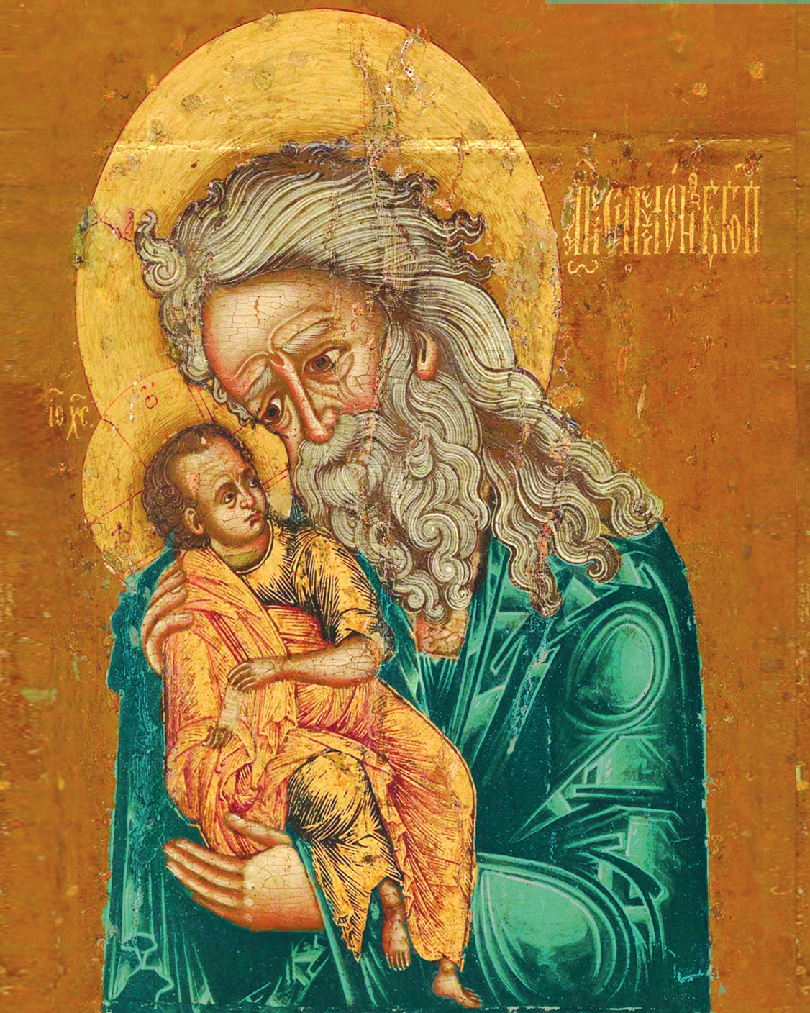

For mine eyes have seen Thy salvation.

